
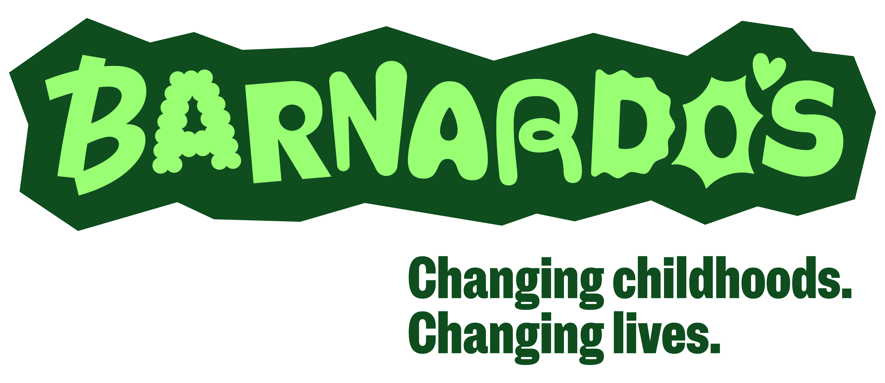
COMMUNITY WELLBEING TEAM
BARNARDO’S REFERRAL FORM

This form is to be used by anyone referring a child/young person to the Barnardo’s Community Wellbeing Team outside of the Mindworks referral pathway.

Surrey Locality
Spelthorne | ◻ | Surrey Heath | ◻
Waverley | ◻ | Woking | ◻

- YOUNG PERSON and FAMILY INFORMATION

Has this CYP previously received support from Barnardo’s? | Y  N   If yes, please identify service:
Family Name: | Forename/s:
Preferred Name: | D.O.B:
NHS Number (mandatory): | GP Surgery, incl. postcode (mandatory):
School/College (incl. postcode):

Home Address (including postcode):

Home Phone: | Young person’s email address and/or phone number (16yrs+):
Gender:  Preferred Pronouns:  Sexual Orientation: | Ethnicity:
Gender:  Preferred Pronouns:  Sexual Orientation: | Religion:
Primary language:  Is an interpreter/signer or additional support required?  Y  N   If yes, please give details | Disability or learning needs (if any):  Any other known medical issues (if any):
EHCP (Education Health Care Plan):  Y  N   If yes, please provide details: | Does the child/young person have a social worker or Family Support Worker?  Current  Historical  Never   If current or historic, please provide details:
Is the child currently on a CIN (Child in Need) or a CP (Child Protection) plan?  Current  Historical  Never   If current or historic, please provide details: | Is the child a Care-Experienced Young Person (previously known as Looked After Child) or a young carer?  Y  N   If yes, please provide details:
Parent/Guardian Name: |  | Phone Number:

Email address:

Parent/Guardian Address (if different):

Has parent/guardian consent been given for this referral?  (If no, state reason) |  | Y  N 
Parent/Guardian Name: |  | Phone Number:

Email address:

Parent/Guardian Address (if different):

Has parent/guardian consent been given for this referral?  (If no, state reason) |  | Y  N 

- REFERRAL INFORMATION

Reason for referral  What does the referrer feel the young person needs support with?  Please place an X in the appropriate box | Emotional Wellbeing Need
 | General anxiety
 | Emotional literacy and regulation
 | Self-esteem/ self-worth
 | Friendships and relationships
 | Low-mood
 | Resilience
 | Anxiety about school attendance or school transition
 | Strategies to manage low-level self harm and suicidal thoughts
 | Other (please describe need)
How do the presenting concerns impact the young person in their daily lives?
Please provide as much detail as possible (eg when did it start, what are the triggers, impact at home/school/ on relationships/ appetite/ sleep etc)

Known risks of young person:
(such as self-harm, suicidal thoughts or aggressive tendencies etc)

Known risks to others:
(such as aggressive behaviour, safeguarding concerns etc)

Known risks from others:
(such grooming/exploitation, bullying, County Lines, domestic abuse etc)

What is going well for the young person?

What kind of support would you like the young person to receive and what are the hoped-for outcomes?

What support has previously been accessed and what was the outcome of this support? Please provide a timeline of when this happened

Voice of the young person:

What does the young person think they need support with?

What would the young person like to get out of support?

Please provide as much detail as possible

Has the young person agreed to this referral being made to Barnardo’s?
(If no, state reason)

Y  N 

Other supporting information

- REFERRER DETAILS

Name of worker completing this referral (Please print)
Agency/Service
Telephone Number
Email Address

D. OTHER AGENCIES INVOLVED
Please name key agencies involved with this young person | Phone Number | Email

Please return forms to the Community Wellbeing Team:

Address: Community Wellbeing Team, Barnardo’s Wellbeing Hub
Regus, Dorset House, Regent Park, Kingston Road, Leatherhead, KT22 7PL
Email: cwt@barnardos.org.uk

